**Title** : Pet store and grooming services management system

### **Team : PES1UG23CS111**

## **ABSTRACT**

The *Pet Store and Grooming Services Management System* is a full-stack application designed to streamline the operations of a pet store offering both retail products and grooming services. The system integrates a robust relational database with an intuitive frontend interface, enabling seamless management of customers, products, services, employees, suppliers, orders, and payments.

The backend database consists of structured tables such as **customer**, **product**, **service**, **orders**, **payment**, **order_product**, **Order_Details**, **customer_service**, **employee**, and **supplier**, ensuring accurate organization of business data. The frontend provides an interactive platform where users can log entries into these tables, manage grooming appointments, update inventory, and track orders with ease. It also features a built-in SQL execution panel that allows users to run SQL queries directly from the interface, along with a *Show Tables* section that displays all available tables dynamically.

By combining an accessible user interface with a well-designed database, the system enhances operational efficiency, improves data accuracy, and supports better decision-making. This integrated solution ensures smooth workflow management for both product sales and grooming services, making it suitable for real-world pet store environments.

## **USER REQUIREMENT SPECIFICATION (URS)**

### **Functional Requirements**

#### **Admin**

* The system shall allow the admin to log in using a secure username and password.
* The system shall display an overview of total customers, products, services, employees, orders, and payments on the admin dashboard.
* The admin shall be able to add, update, view, and delete customer details.
* The admin shall be able to view customer purchase and service history.
* The admin shall be able to add new products with price, category, and quantity.

**Non admin**

* The user shall be able to browse all available pet products.
* The user shall be able to see product details such as price, description, and stock availability.
* The user shall be able to see service details such as duration, price, and type.
* The user shall be able to see all the tables

**Non-Functional Requirements**

#### **Security**

* Unique emails and phone numbers
* Role-based access control

#### **Performance**

* Stored procedures reduce overhead

#### **Usability**

* Simple, responsive UI.
* Clear navigation for all roles

## **SOFTWARE / TOOLS / LANGUAGES USED**

| **Component** | **Technology** |
| --- | --- |
| Frontend | HTML5, CSS, |
| Backend | Python Flask |
| Database | MYSQL Version 9.4 |
| Tools | Vs code , Mysql CLI |
|  |  |

## **ER Diagram & Relational Schema**

[Link for ER Diagram](https://drive.google.com/drive/folders/1rqe3WWP6-Rv_-UPeNLw0Yym7zVbR9eJN)

## **DDL& DML COMMANDS**

The DDL (Data Definition Language) and DML (Data Manipulation Language) commands needed are all contained in the file named **“pet_store_and_ services.sql”**. This file is located in the project folder.

## **CRUD OPERATION SCREENSHOTS**

**Creating a customer**

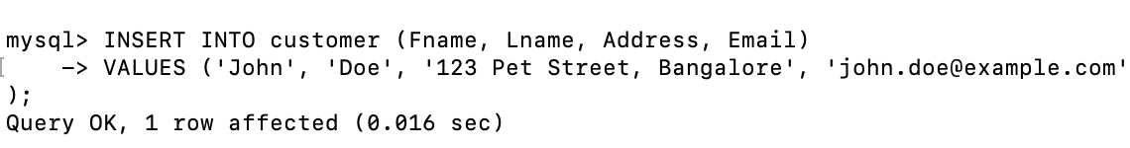

**Reading the table of customers**

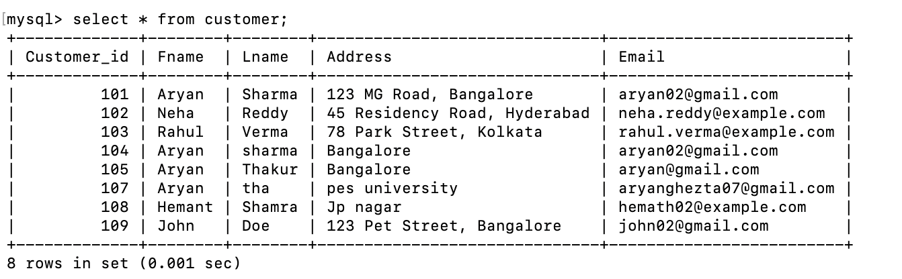

**Updating the email id of customer hemant sharma**

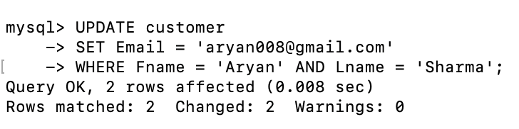

**Deleting the customer id 107**

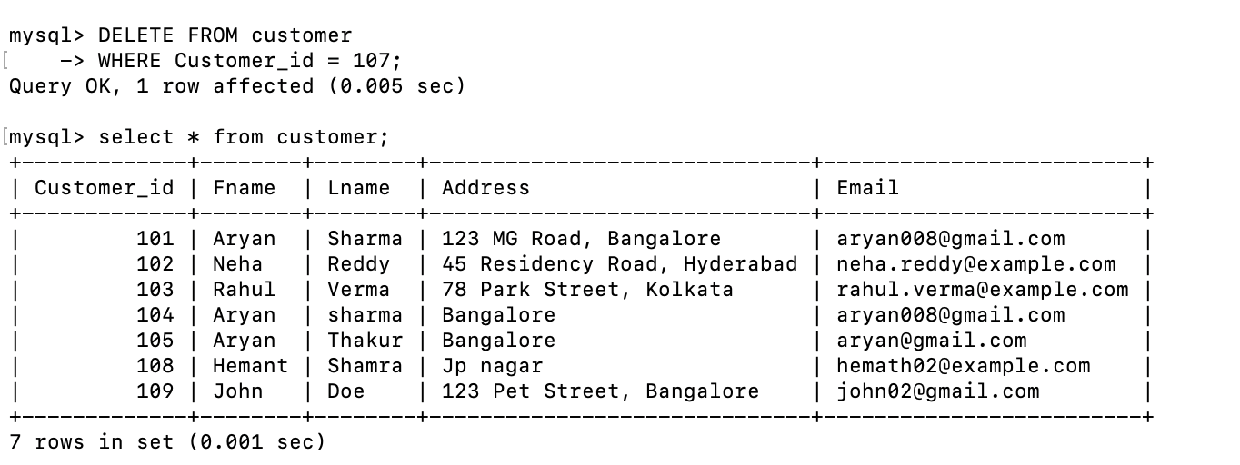

## **FUNCTIONALITIES & FRONTEND SCREENSHOTS**

**Dashboard**

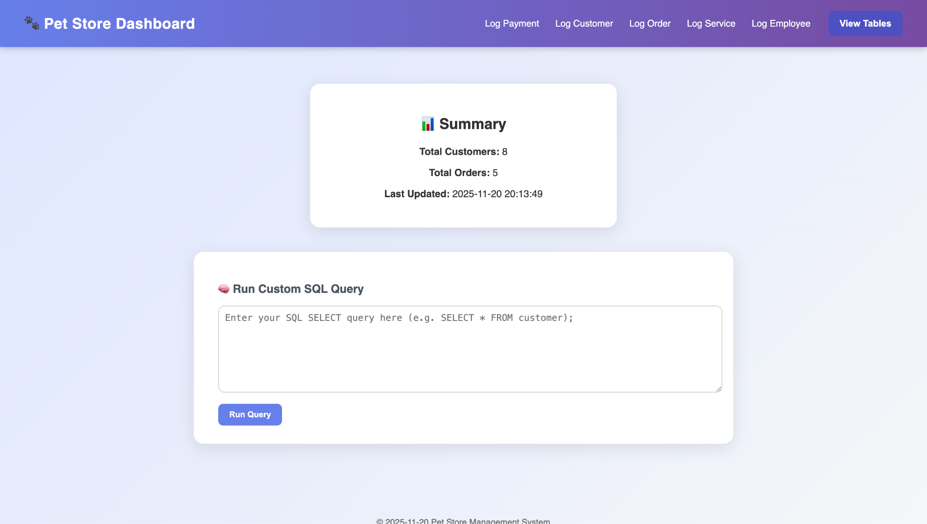

**Some Log options**

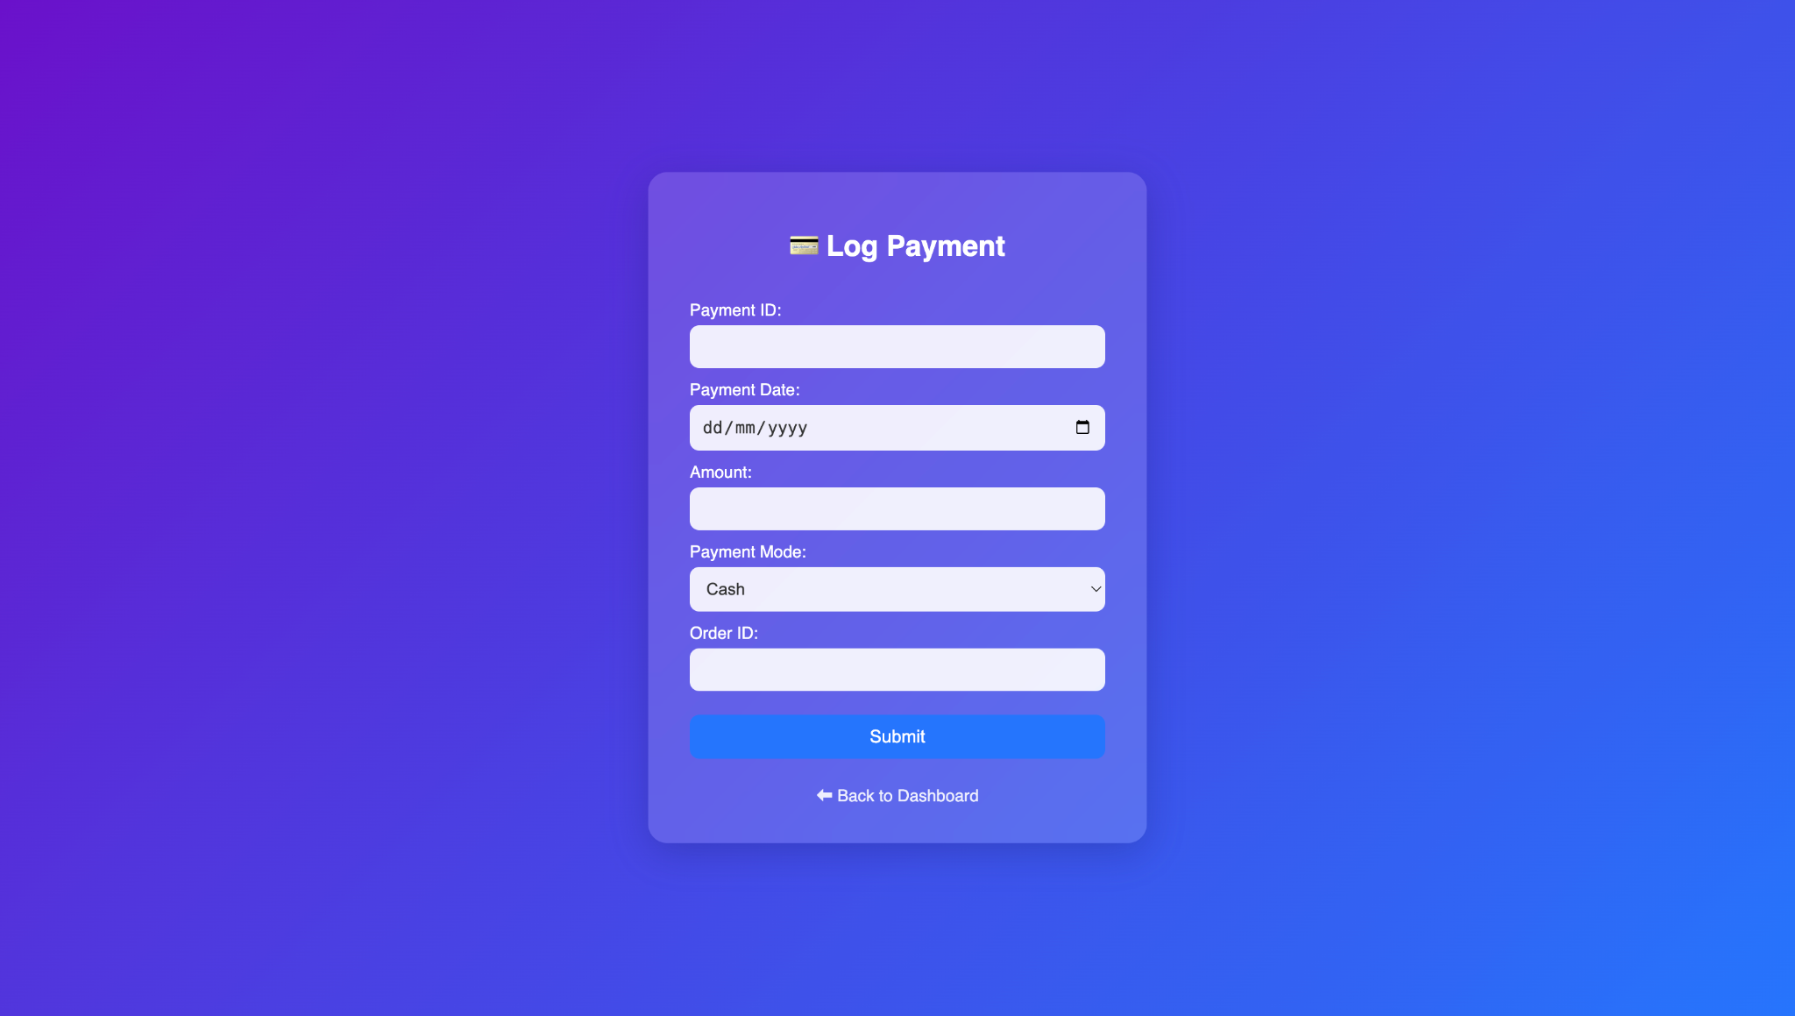

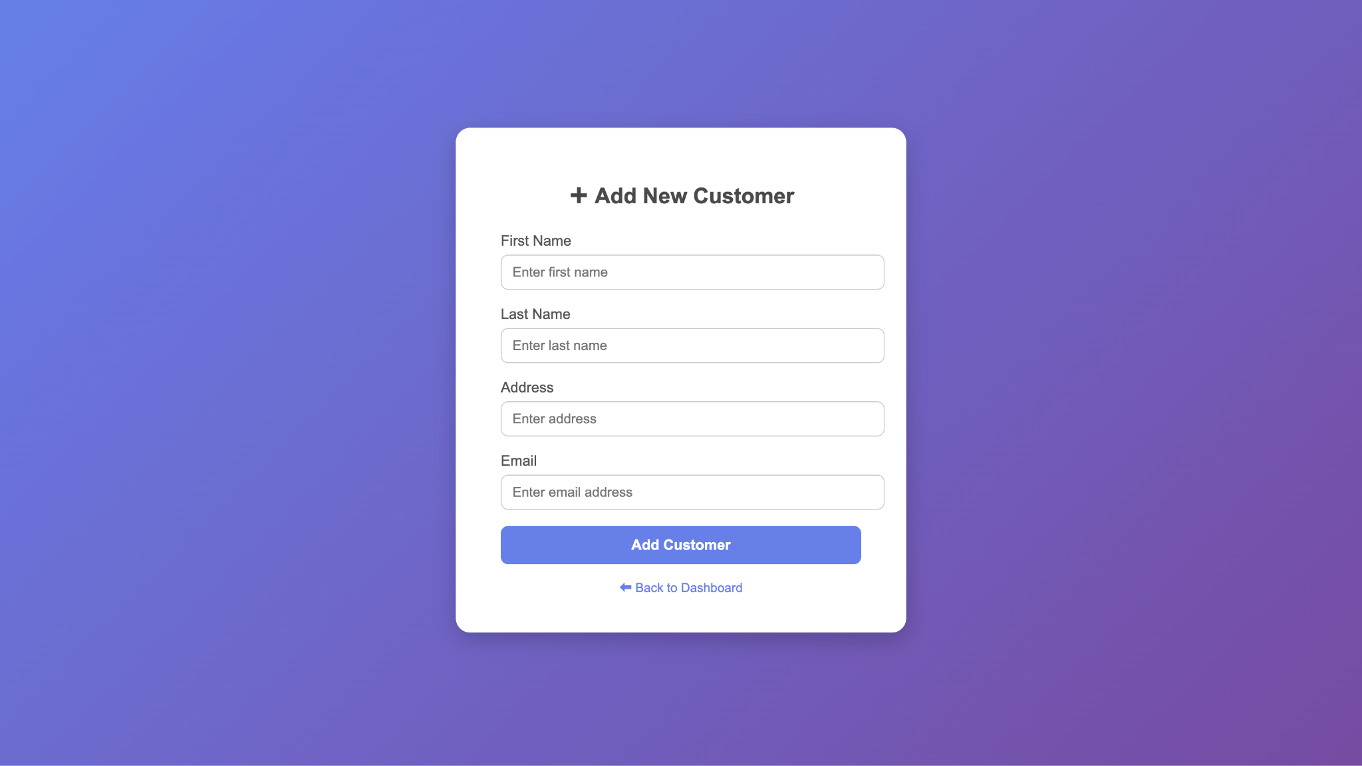

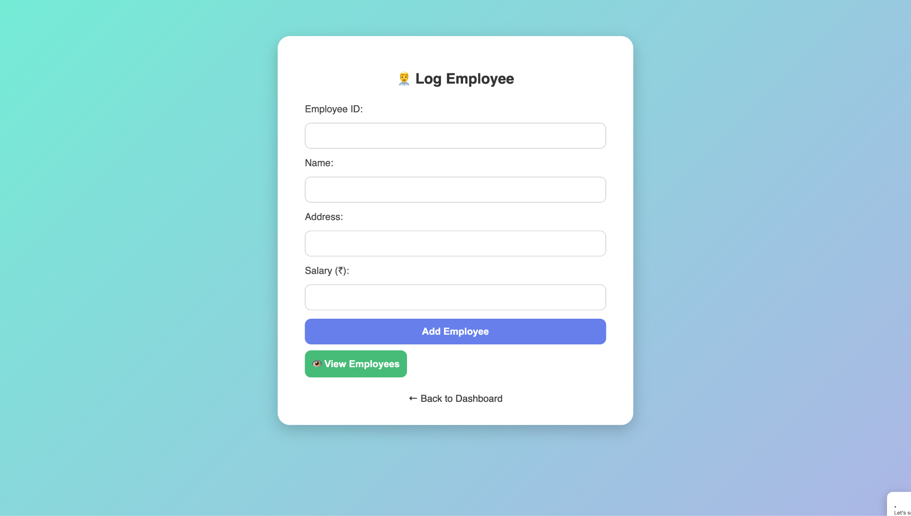

**View tables option**

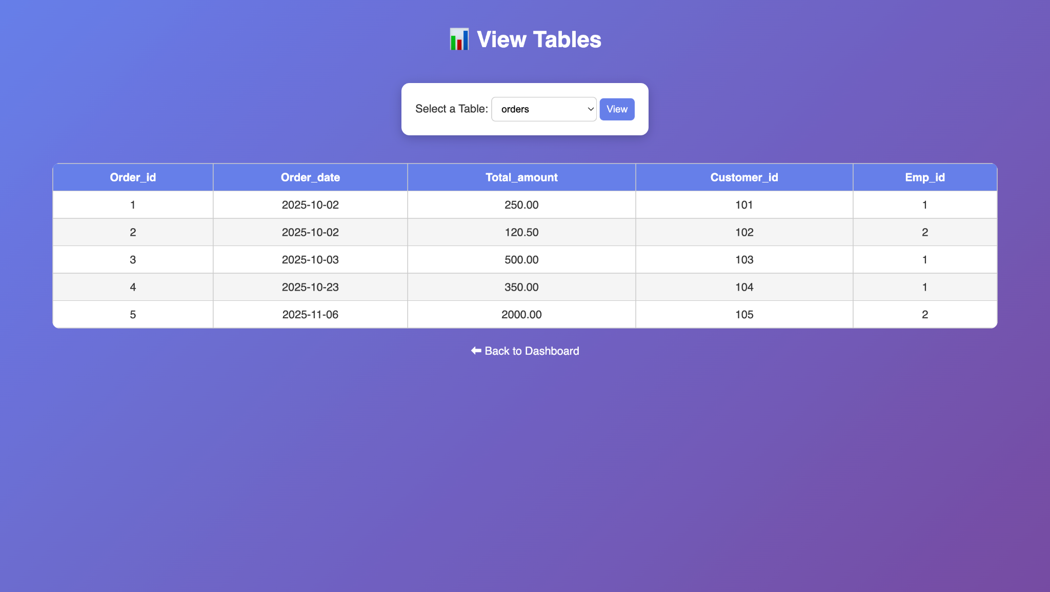

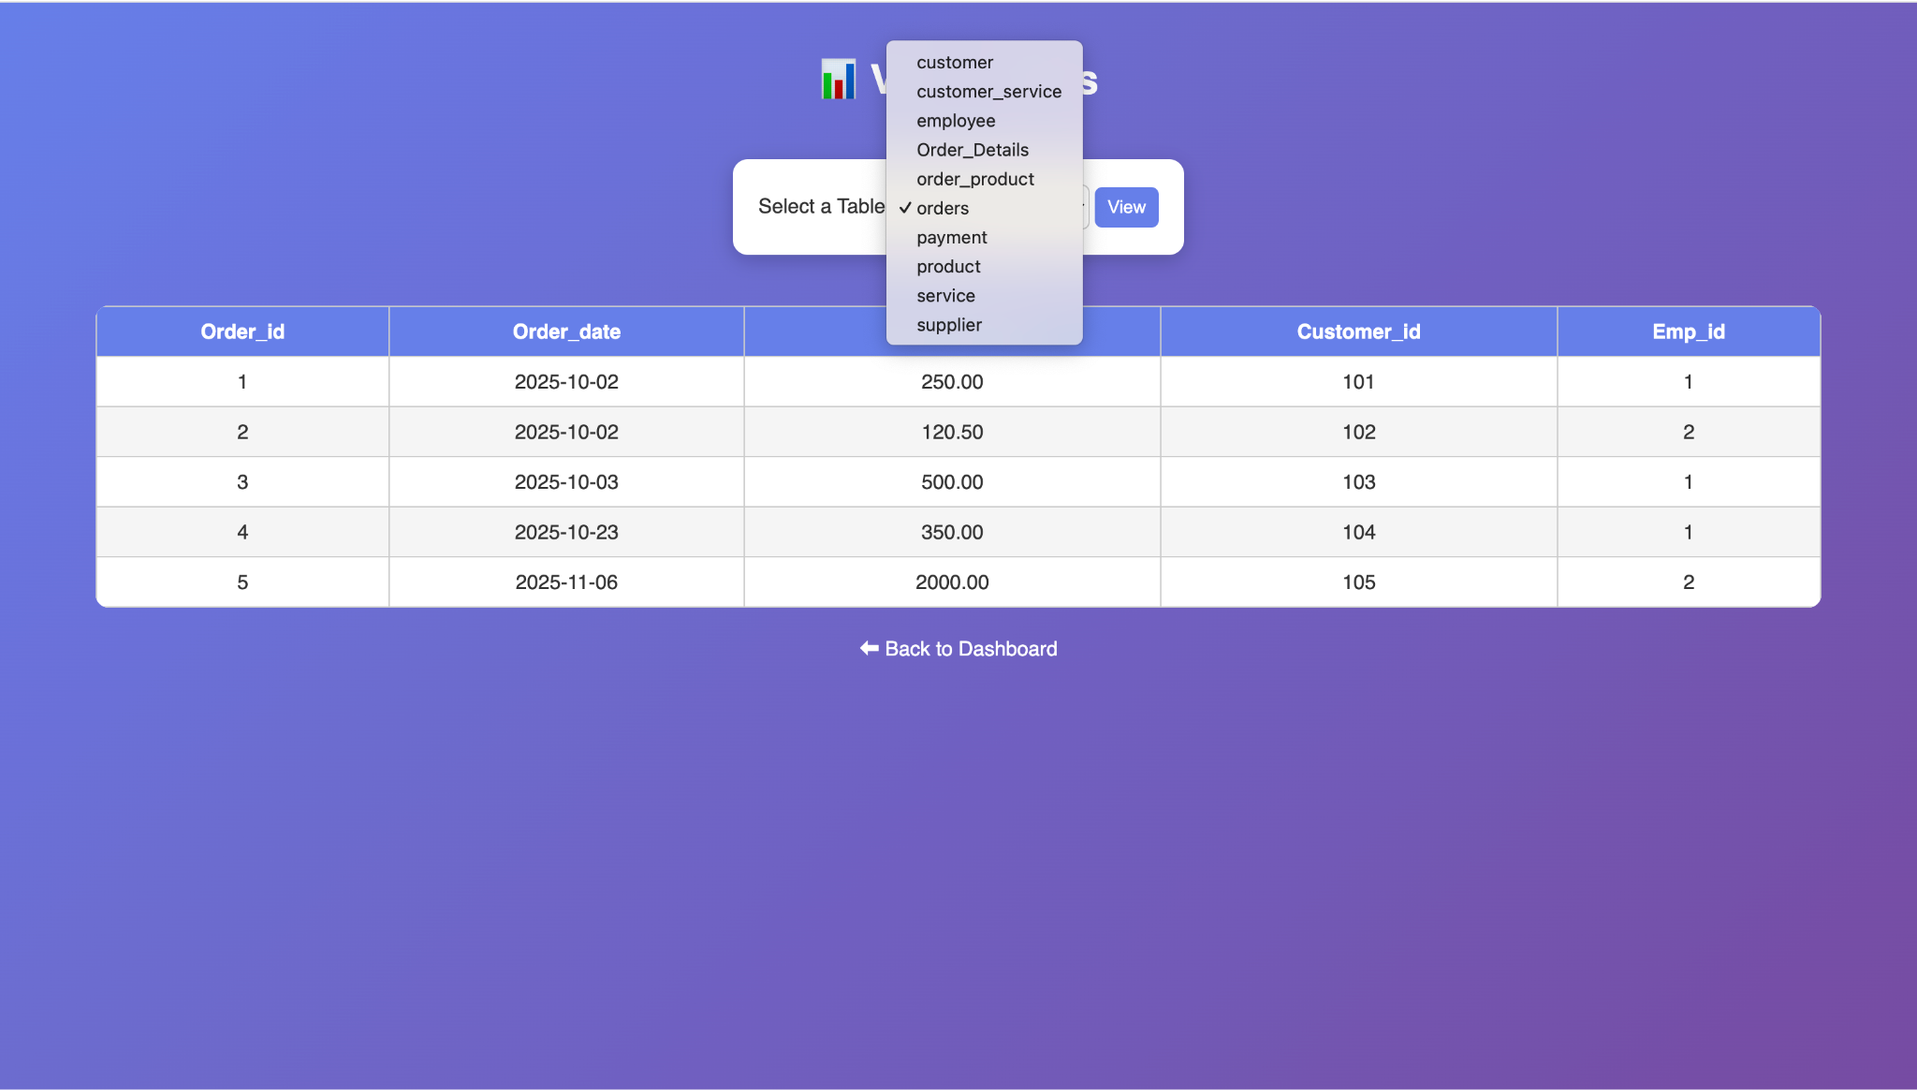

**Custom sql query runner**

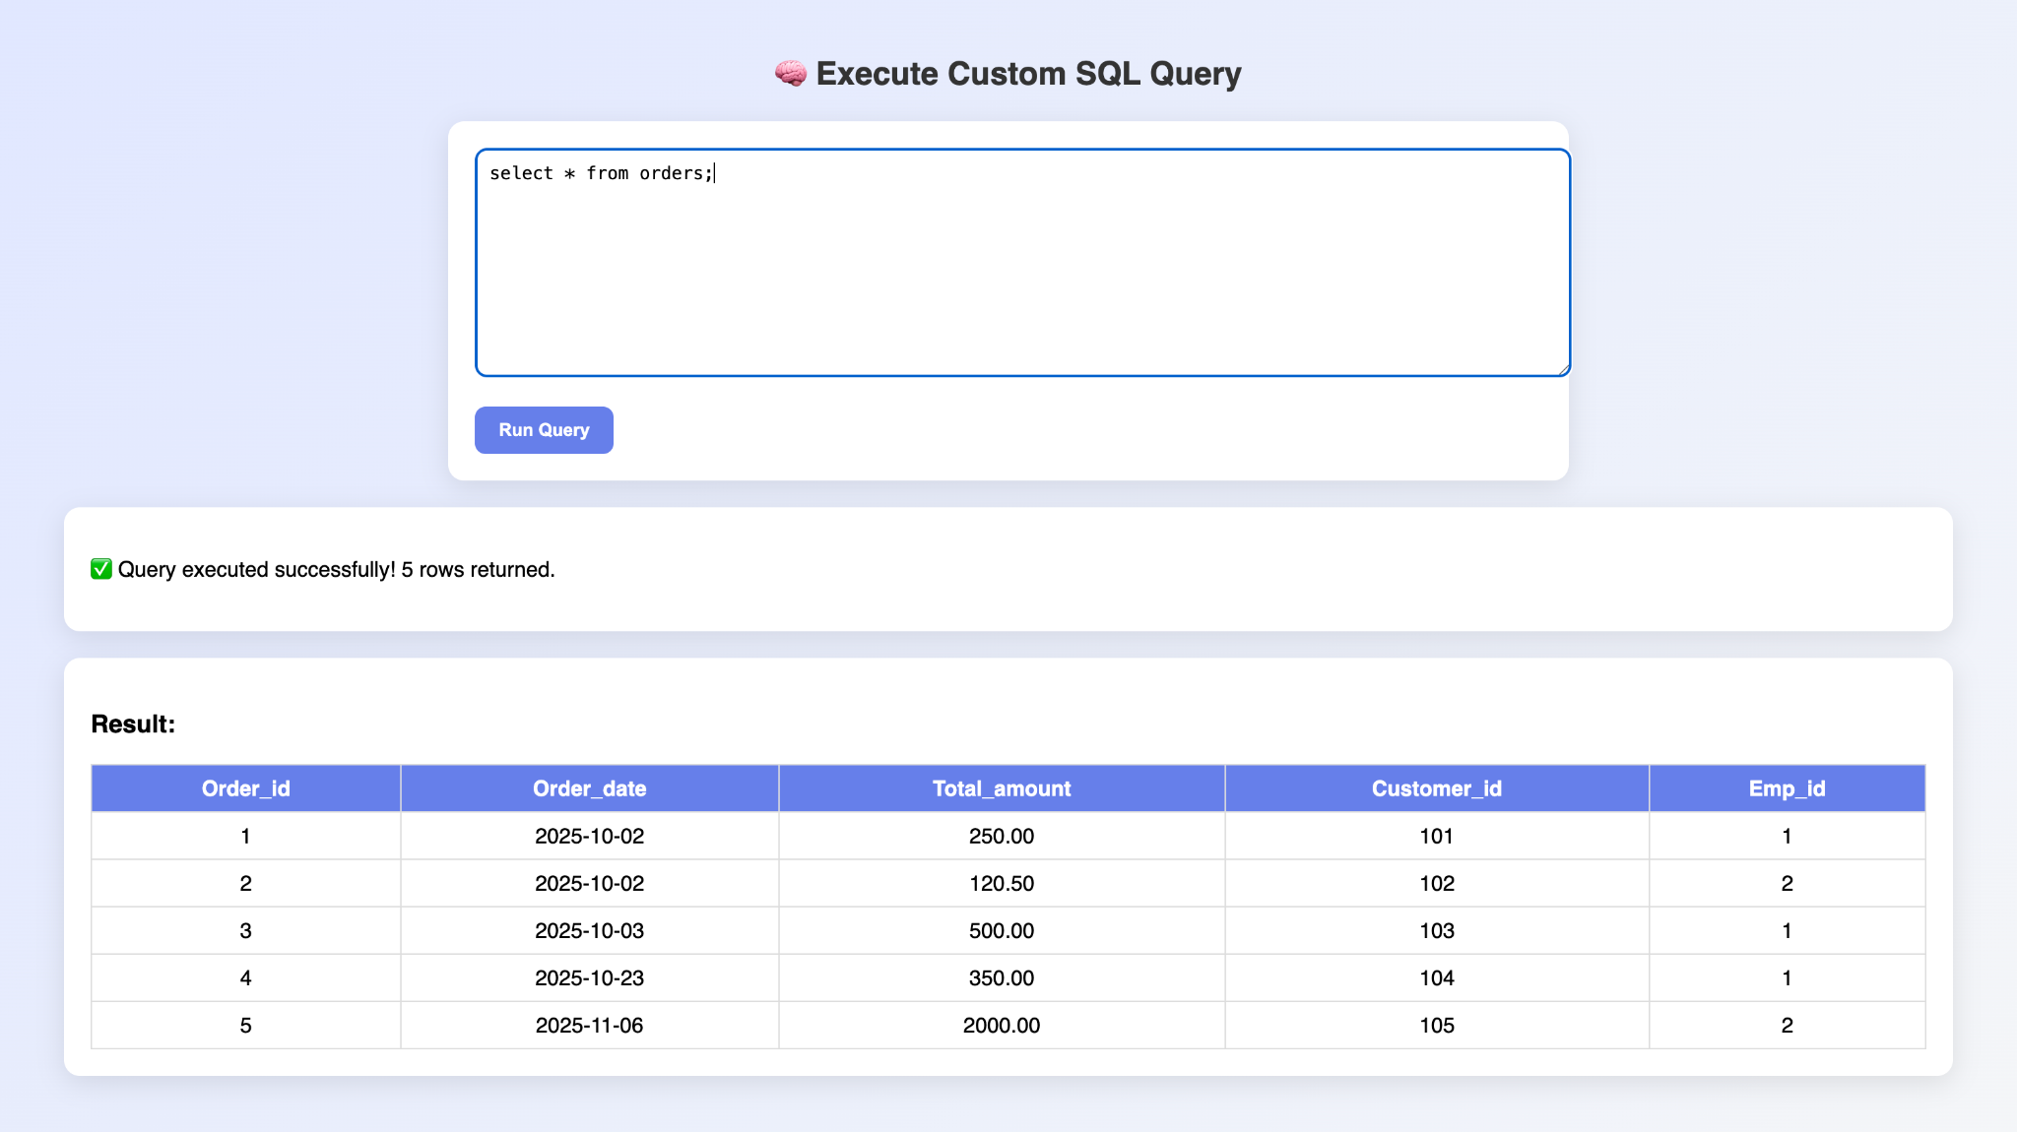

## **TRIGGERS, STORED PROCEDURES & FUNCTIONS**

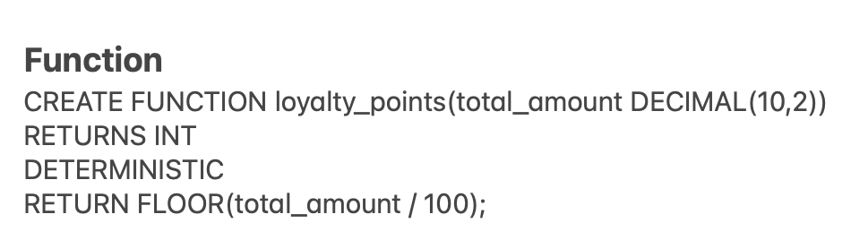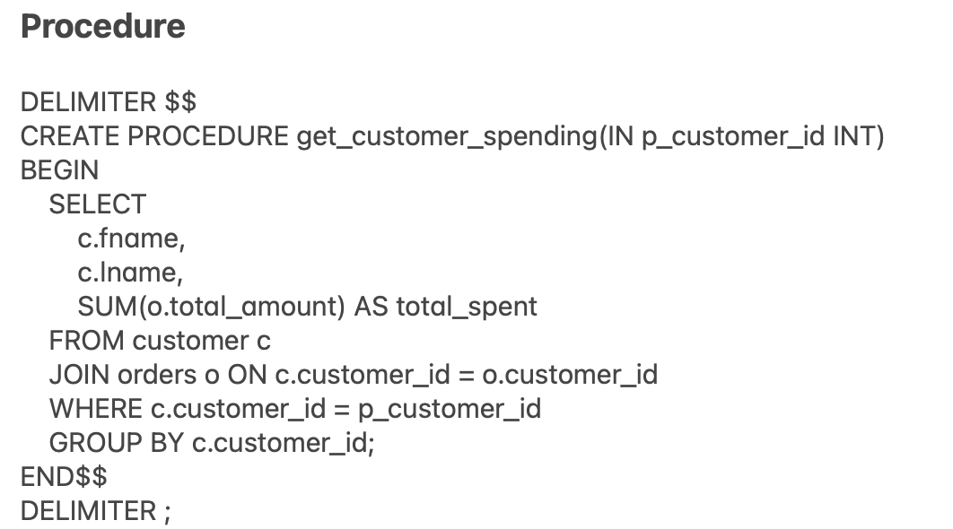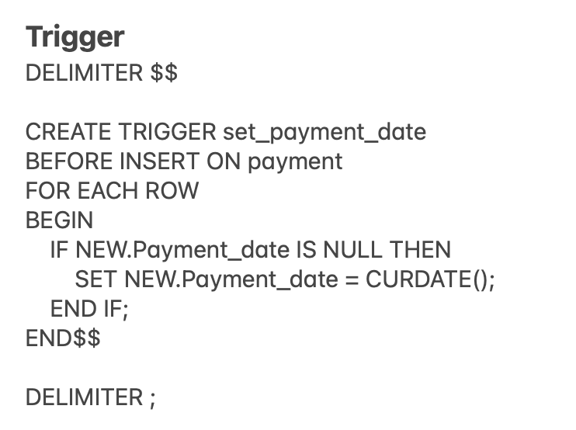  
Triggers, Stored Procedures, and Functions are declared in the **"REVIEW-3.sql"** file within the project folder

## **Code snippets for invoking the Procedures/Functions/Trigger**

Trigger



Function

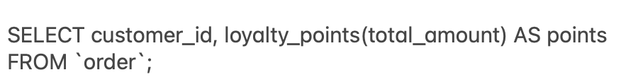

Procedure

